**Department of Computer Science and Engineering**

| **Course Code: CSE370** | **Credits: 1.5** |
| --- | --- |
| **Course Name: Database Systems** | **Semester: Spring 2024** |

**Lab 01  
Part A: Setting Up and Connecting to the MySQL Server**

**Activity List for Part A**

**Step 1:** Go to <https://www.apachefriends.org/index.html> and download XAMPP for your OS.

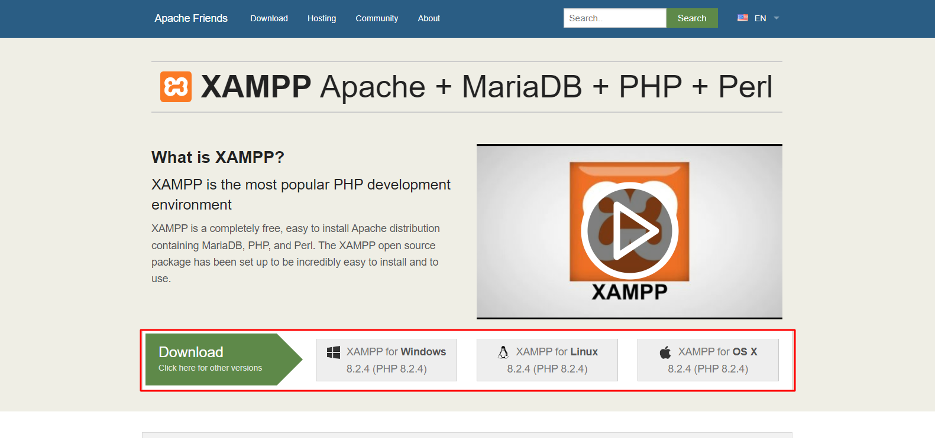

**Step 2:** Install XAMPP according to the installation guide.

**Step 3:** Open the XAMPP control panel after installation.

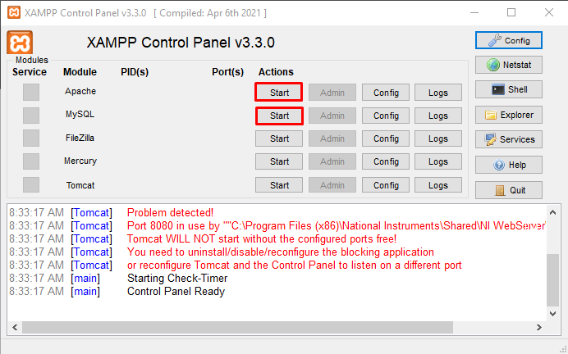

Open the control panel and click the start buttons (highlighted in red) beside Apache and MySQL.

**Step 4: Click on the “shell” button on the right of the window**

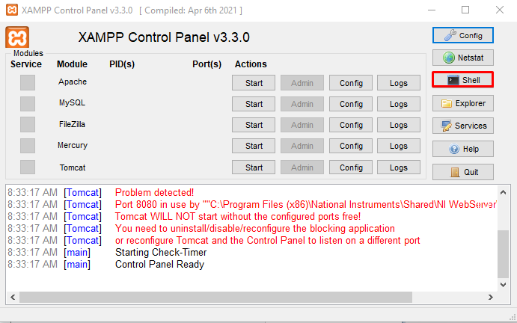

**Step 5: Connect to the MySQL server**

After clicking on the shell, you should see a black window. Type in the following command:

**mysql -u root -p**

When you are asked for a password, don't type anything just press enter. **The default password for xampp is an empty string.**

**Part B : An Introduction to MySQL Queries**

Syntax error in a query might cause the mysql> prompt not to appear after executing the query.

**Solutions:**

* + 1. Typing one of the following may solve the problem
       1. ');
       2. `);
       3. `;
       4. ';
       5. Or log out with ctrl+c and log in again

**Activity List for Part B**

* **All commands are shown in the red boxes.**
* **In the green box, write the response you see after entering each query. Also, write the query for cases where you had to make changes.**
* **The part of the query in bold italic are variables, the rest are keywords. Sometimes, you might need to change the variables as per requirement.**
* **All new queries should be typed in the command window after mysql>**























| **std_id** | **name** | **major** | **section** | **days_present** | **project_marks** | **cgpa** | **submission_date** |
| --- | --- | --- | --- | --- | --- | --- | --- |
| s001 | Abir | CS | 1 | 10 | 18.5 | 3.91 | 2018-09-15 |
| s002 | Nafis | CSE | 1 | 12 | 20 | 3.86 | 2018-08-15 |
| s003 | Tasneem | CS | 1 | 8 | 18 | 3.57 | 2018-09-18 |
| s004 | Nahid | ECE | 2 | 7 | 16.5 | 3.25 | 2018-08-20 |
| s005 | Arafat | CS | 2 | 11 | 20 | 4.0 | 2018-09-13 |
| s006 | Tasneem | CSE | 1 | 12 | 17.5 | 3.7 | 2018-08-15 |
| s007 | Muhtadi | ECE | 1 | 10 | 19 | 3.67 | 2018-09-16 |
| S008 | Farhana | CSE | 2 | 6 | 15 | 2.67 | 2018-08-16 |
| s009 | Naima | CSE | 2 | 12 | 20 | 3.7 | 2018-08-14 |

**Link for Table Data:** [**https://docs.google.com/document/d/1XGp65Cd1KR6u6K61EraK6FpQrfAt5ZnonwvQvuWGK2U**](https://docs.google.com/document/d/1XGp65Cd1KR6u6K61EraK6FpQrfAt5ZnonwvQvuWGK2U)









**Part C : SQL Alter, Update, Delete & Basic Select Queries**

**Task 1: Modifying Columns of a Table:**







* How will you change the name of a column from submission_date to sub_date? **[Google it!]**

**Task 2: Updating Wrong Data:**





* What will happen if the where clause is not included in the update query, e.g . if you typed Update Lab_Grades set Major = ‘CSE’;? [**Don’t try it now, just write the answer**]



**Task 3: Deleting Data:**



* What would have happened if there was another student named Naima?



**Task 4: Deleting Table or Database [DO NOT TRY NOW]:**



**Task 5: Retrieving Data from Table:**

* What is the [**select * from Lab_grades;]** command used for?







* The “as” keyword in the above query is known as an alias. Check out what happens if you remove the “as Total_marks” portion from the above command. State the difference below.



* Try the command below, and state what the Upper() and Lower() functions mean.





* Try the two commands below. What is the difference and why is the distinct keyword used?





* Was it sorted in ascending or descending order? How can you sort in the opposite order?[Hint: check next command]





* Retrieve the names, days present and marks of students whose project marks are greater than 17





* What is the “in” keyword in the above query? In the where clause, you can write the same command using the “or” and “=” operators. Try to figure it out!





* How can you find the students whose Submission_date is not in August?







* Try the following command and explain what happens : Select ***\**** from ***Lab_Grades*** where ***Name*** like ‘a___’; ***[There are 3 underscores]***

**Task 6: Basic Select Quiz**

Go to <https://sqlzoo.net/wiki/SELECT_Quiz> and answer the Quiz to test your knowledge of basic select queries.